 | SR UNIVERSITY  Campus Warangal
 | Program: II - B. Tech (CS & AI) Batch: 57(DATA SCIENCE)
 | Name: Perkari Himank Rao Reg. No: 2503A54028
 | Department: Computer Science and AI Semester: III
 | AI Assisted Coding-Assignment: 8 Date: 21/09/2026
Q1. Debugging Input Validation
1.QUESTION
Debug the given Python student marks program. Identify at least three problems, use AI to explain the bugs before rewriting, correct the program, validate marks from 0–100, handle non-numeric input, test at least five inputs, and record which AI suggestions were accepted or rejected.
2.PROMPT
“Debug this Python program systematically. Identify the errors, explain why each error occurs, and suggest how to fix them. Do not rewrite the complete program yet.”
3.BUG ANALYSIS
Bug / Problem | Cause | Fix
Incorrect average calculation | Division happens before the earlier additions, so only mark3 is divided by 3. | Use (mark1 + mark2 + mark3) / 3.
No mark range validation | Values below 0 or above 100 are accepted. | Check 0 <= mark <= 100.
Non-numeric input causes ValueError | int(input()) fails when text such as abc is entered. | Use try-except around numeric conversion.
No input recovery | An invalid entry terminates the program. | Use a validation loop and ask again.

The original program therefore needs both arithmetic correction and input validation before its Pass/Fail result can be trusted.
4.CORRECTED CODE
def read_mark(number):
while True:
try:
mark = float(input(f"Enter Mark {number}: "))
if 0 <= mark <= 100:
return mark
print("Invalid mark. Enter a value from 0 to 100.")
except ValueError:
print("Invalid input. Enter a numeric mark.")

name = input("Enter student name: ")
mark1 = read_mark(1)
mark2 = read_mark(2)
mark3 = read_mark(3)

average = (mark1 + mark2 + mark3) / 3

if average >= 50:
print(name, "Pass")
else:
print(name, "Fail")

print(f"Average: {average:.2f}")

5.OUTPUT
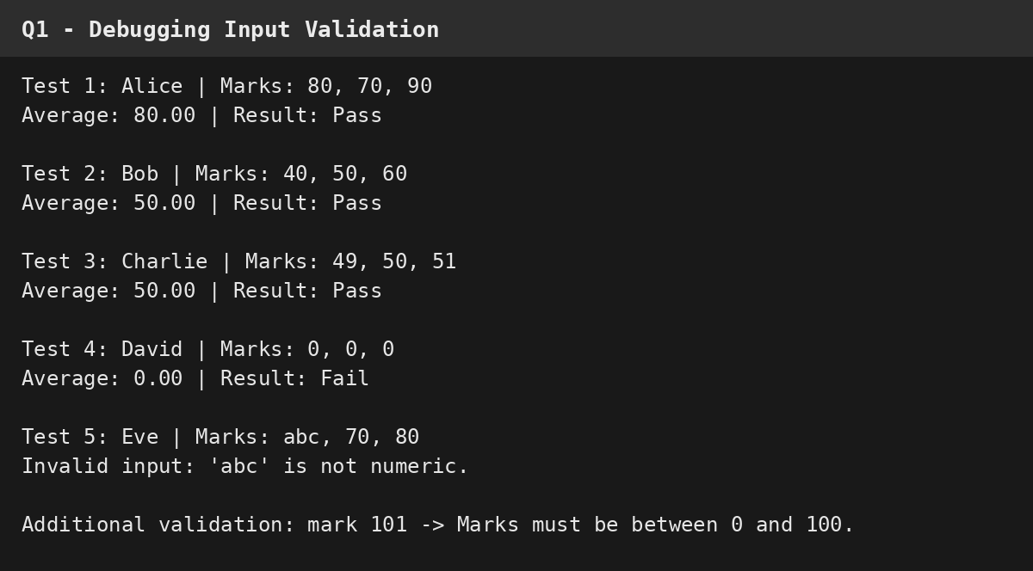
6.AI SUGGESTIONS ACCEPTED / REJECTED
• Accepted: Correct the operator-precedence error with parentheses.
• Accepted: Validate every mark in the 0–100 range.
• Accepted: Use try-except for non-numeric input.
• Accepted: Use a retry loop so invalid entries do not crash the program.
• Rejected initially: A complete rewrite was not used before the bugs were understood, following the assignment instruction to debug systematically first.
7.OBSERVATION
The corrected program calculates the average correctly, accepts only marks from 0 to 100, and handles non-numeric input without crashing. The required tests include normal, boundary, zero, and invalid-input cases.
Q2. Debugging Loops and Conditions
1.QUESTION
Find the logical errors in the given loop program, use AI to explain why the output is wrong, correct the loop and condition, test n = 10, n = 20 and n = 1, verify the results manually, and write a short debugging explanation.
2.PROMPT
“Analyze this Python loop program. Trace the loop for n = 10, identify why the output does not represent the sum of even numbers, and suggest the smallest corrections. Do not rewrite the complete program yet.”
3.BUG ANALYSIS
Bug / Problem | Cause | Fix
Wrong parity condition | i % 2 == 1 selects odd numbers although the required output is the sum of even numbers. | Use i % 2 == 0.
Upper limit excludes n | range(1, n) stops at n-1. | Use range(1, n + 1).
Logic and output label disagree | The program prints “Sum of even numbers” while adding odd numbers. | Correct the condition so the calculation matches the label.

For n = 10, the original logic adds 1 + 3 + 5 + 7 + 9 = 25. The corrected logic adds 2 + 4 + 6 + 8 + 10 = 30.
4.CORRECTED CODE
n = int(input("Enter n: "))

total = 0

for i in range(1, n + 1):
if i % 2 == 0:
total += i

print("Sum of even numbers =", total)

5.OUTPUT
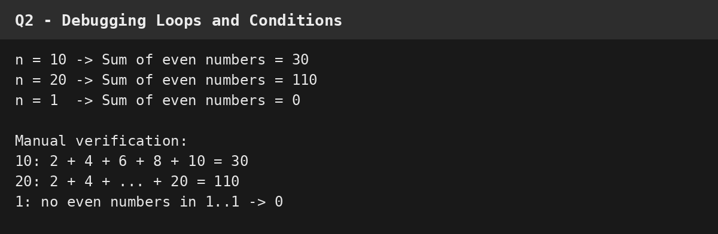
6.DEBUGGING EXPLANATION
The corrected range includes n, and the condition checks for even values using remainder 0 when divided by 2. The results were manually verified: n = 10 gives 30, n = 20 gives 110, and n = 1 gives 0.
7.OBSERVATION
The logical errors were caused by selecting odd numbers and excluding the upper boundary. After correcting both, the program produces the expected results for all three required test values.
Q3. Debugging Functions and Return Values
1.QUESTION
Identify the function-related bug, check input combinations and boundary cases, use AI to trace function execution, fix the program, test the four specified inputs, and explain the importance of return statements.
2.PROMPT
“Trace the execution of find_largest(a, b, c) for the given test cases. Identify the function-related error and any logical case that can return the wrong largest value. Suggest targeted fixes before providing the complete corrected program.”
3.BUG ANALYSIS
Bug / Problem | Cause | Fix
Missing return statement | find_largest() assigns largest but never sends the value back to the caller. | Return the selected value.
Incomplete comparison logic | When a > b, the code selects a without checking whether c is larger. | Compare the selected value against both other values.
Equality case is not explicit | The original a > b condition skips a == b. | Use >= comparisons to handle equal values.

For (30, 20, 40), the original program enters the a > b branch and chooses 30 even though 40 is largest. This demonstrates why all three values must be considered.
4.CORRECTED CODE
def find_largest(a, b, c):
if a >= b and a >= c:
return a
elif b >= a and b >= c:
return b
else:
return c

def display_result(x):
print("Largest number =", x)

x = int(input("Enter first number: "))
y = int(input("Enter second number: "))
z = int(input("Enter third number: "))

result = find_largest(x, y, z)
display_result(result)

5.OUTPUT
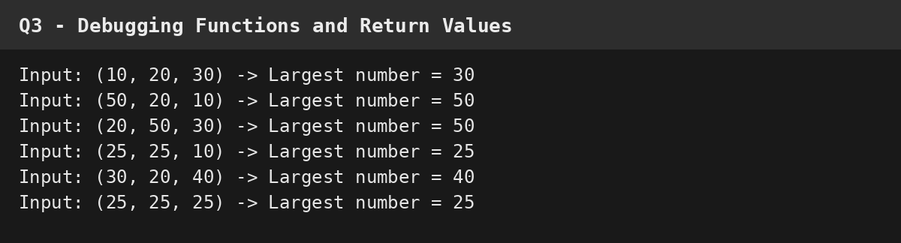
6.RETURN STATEMENT EXPLANATION
A return statement sends a computed value from a function back to the calling code. Without return, find_largest() finishes without providing the largest number, so result becomes None.
7.OBSERVATION
The corrected function returns the largest value and handles the specified cases plus additional boundary cases, including equal values and a case where the third number is largest.
Q4. Debugging a Student Result Program
1.QUESTION
Identify at least five bugs or boundary-condition problems, use AI for systematic analysis, create a bug report, correct the program, validate marks from 0–100, handle non-numeric input, verify grade boundaries, test at least eight cases, compare the original and corrected versions, and explain how AI helped.
2.PROMPT
“Debug this student result program systematically. Identify at least five bugs or boundary-condition problems, explain each cause, and suggest targeted fixes. Verify the grade and pass/fail boundaries and input validation before providing a complete corrected program.”
3.BUG REPORT
Bug / Boundary Problem | Cause | Correction
Grade boundary uses > 90 | Average exactly 90 does not receive A+. | Use >= 90.
Other grade boundaries use strict > | Exact values 75, 60 and 50 fall into the lower grade. | Use inclusive >= boundaries.
Pass condition uses min(marks) > 40 | A mark exactly 40 is treated as Fail. | Use min(marks) >= 40.
No 0–100 validation | Negative or over-100 marks can affect the result. | Validate every mark.
Non-numeric input is not handled | int(input()) raises ValueError for text. | Use try-except.
No retry for invalid data | The input process stops after invalid data. | Loop until a valid mark is entered.
Grade rules are not documented | The boundary convention is not made explicit. | Document and test the selected boundaries.

For the corrected report, the grade boundaries used for testing are: A+ for average >= 90, A for average >= 75, B for average >= 60, C for average >= 50, and F otherwise. Pass requires every mark to be at least 40.
4.CORRECTED CODE
def calculate_result(name, marks):
total = sum(marks)
average = total / len(marks)

if average >= 90:
grade = "A+"
elif average >= 75:
grade = "A"
elif average >= 60:
grade = "B"
elif average >= 50:
grade = "C"
else:
grade = "F"

status = "Pass" if min(marks) >= 40 else "Fail"

print("Student:", name)
print("Total:", total)
print("Average:", average)
print("Grade:", grade)
print("Status:", status)

def read_mark():
while True:
try:
mark = int(input("Enter mark (0-100): "))
if 0 <= mark <= 100:
return mark
print("Invalid mark. Enter a value from 0 to 100.")
except ValueError:
print("Invalid input. Enter a numeric mark.")

name = input("Enter name: ")
marks = [read_mark() for _ in range(3)]
calculate_result(name, marks)

5.OUTPUT
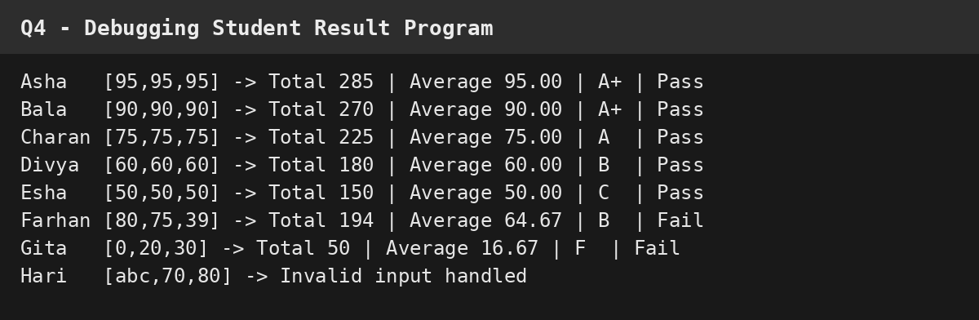
6.ORIGINAL vs CORRECTED
Aspect | Original Version | Corrected Version
Average | Calculated from the list. | Same calculation after input validation.
Grade boundaries | Strict > comparisons. | Inclusive >= boundaries.
Pass condition | Every mark must be > 40. | Every mark must be >= 40.
Input validation | None. | Only numeric marks from 0 to 100 are accepted.
Invalid input | Can terminate with ValueError. | Caught and retried.
Boundary testing | Not explicitly verified. | Exact grade boundaries and pass/fail cases are tested.

7.AI ASSISTANCE
• AI was used first to trace the existing logic and identify boundary and input-validation problems rather than immediately replacing the whole program.
• The suggested fixes were checked against the original code and then incorporated into the corrected version.
• The corrected program was tested with eight cases, including exact grade boundaries, failing marks, and invalid input.
• The final code was accepted only after the test outputs matched the intended rules.
8.OBSERVATION
The corrected program handles grade boundaries consistently, validates marks from 0 to 100, and prevents non-numeric input from crashing the program. The eight tests demonstrate A+, A, B, C and F outcomes, Pass/Fail behavior, and invalid-input handling.

